EXAMINATION CASE STUDY
STAGE 3
2008/17760[v2]

[Adapted from: Victorian Curriculum and Assessment Authority. (2006). Information Systems: Written examination: Victorian Certificate of Education 2006 (case study insert). Retrieved April, 2008, from http://www.vcaa.vic.edu.au/vce/studies/infotech/infosystems/pastexams/2006infosys-w.pdf]
Case Study Descriptions

Lucky Orchids Case Study
Lucy is the owner of Lucky Orchids which specialises in growing orchids for the pot plant market.

Lucy’s current system
Her nursery, a 600 square metre heated greenhouse, is located next to her house. The greenhouse is divided into three rooms that have different growing conditions for different stages of a plant’s life. Each room has its own set of climate control units that can be set according to the needs of the plants in that room. Lucy can only check each unit by going into the greenhouse and reading the climate gauges in each room.

On a recent trip to Holland, to purchase new varieties of plants, she noted that Dutch nurseries were using a computer system to monitor and control the climate in their greenhouses. Having all the sensors and climate control devices connected to a computer allowed them to grow plants from seedling to flowering in a much shorter time.

Lucy’s new system
Lucy recently has purchased a new nursery five kilometres from her house. Her new greenhouses will have to be upgraded for her orchids, so Lucy has decided that she wants to introduce a computer controlled climate system into both her existing local nursery and her new remote nursery.

She would like this computer climate control system to
- combine control of all climate devices to produce better conditions for orchid growth
- allow her to remotely check and alter the conditions in each greenhouse room in both nurseries
- record errors and send an alert message to her mobile phone if something fails.

Lucy has decided she needs some help to introduce her new computer climate control system for her greenhouses. She employs a system analyst, Susan, and outlines her current system and what she would like to achieve with the new system.

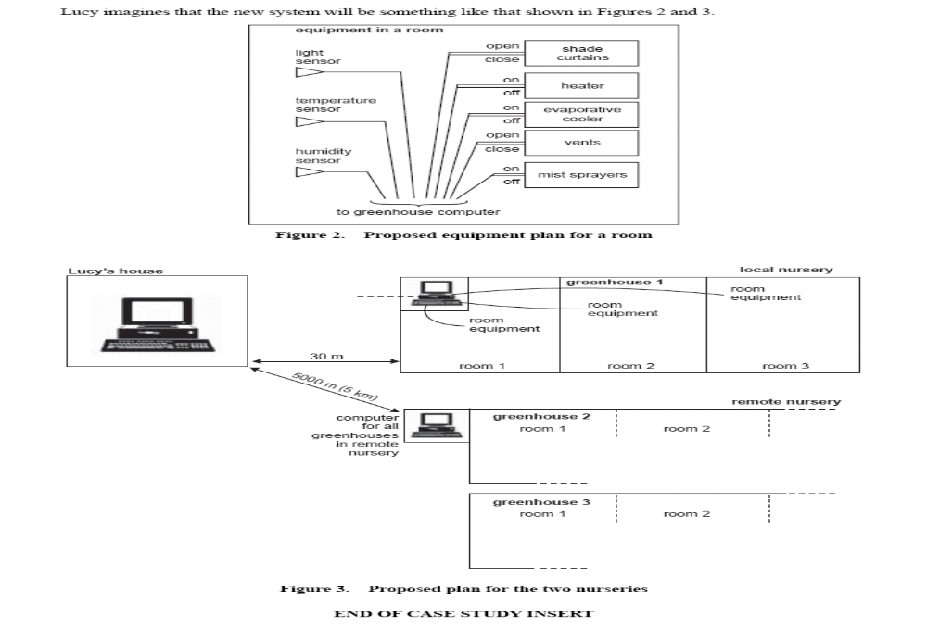
The Astro Hockey Club Database Case Study
The Astro Hockey Club wants to record details about coaches, teams and the equipment kits that have been allocated to the teams for the season. Thomas, one of the coaches, has created the tables below to store the club’s data.

Each team can borrow one or more kits, and over time, each kit can be borrowed by more than one team. Thomas has created the table tblEquipAllocations, to accommodate this situation. Similarly a coach can train more than one team and a team can have more than one coach.

Study the tables below that Thomas has created:

tblCoaches
CoachID | Surname | Firstname | Street | Suburb | Postcode | fCoachRating
1 | Cropper | John | 911 Millgate Road | SPORTSVILLE | 6108
2 | Eggleston | George | 6 Stedman Street | CROSSPATCH | 6149
3 | Green | Hannah | 117 Stanley Loop | KINGSTON | 6009
4 | Hill | John | 316 Gratwick Drive | SPORTSVILLE | 6108
5 | Jones | Margaret | 910 Downsborough Street | KEWDALE | 6105
6 | Mackrie | James | 516 First Ave | CLIFTON BEACH | 6076
7 | Morley | Joseph | 915 Voyager Way | SPORTSVILLE | 6108
8 | Parry | Sarah | 5 Grigo Ave | SPRINGVALE | 6169
9 | Richardson | James | 914 Carlow Circle | WILBURY | 6152
10 | Smith | Thomas | 6 Samson Drive | FRAMTON | 6160
11 | Todd | Nicholas | 917 Carissa Court | MERRIVALE | 6058

tblEquipAllocations
KitAllocationID | fTeamID | fEquipKitID | DateTaken | DateReturned | Deposit
1 | 1 | 1 | 8/04/2001 | 31/05/2001 | 15
2 | 1 | 6 | 19/04/2001 | 31/05/2001 | 15
3 | 3 | 5 | 8/04/2001 | 10/04/2001 | 30
4 | 4 | 2 | 9/04/2001 |  | 15
5 | 4 | 7 | 27/04/2001 |  | 15
6 | 6 | 1 | 3/06/2001 |  | 15
7 | 3 | 5 | 6/05/2001 | 7/05/2001 | 30
8 | 2 | 7 | 12/05/2001 | 13/05/2001 | 15
9 | 2 | 3 | 13/05/2001 | 15/05/2001 | 15

tblEquipKits
EquipKitID | Kit Code | Description | SuggestedDeposit
1 | JSS01 | Junior Stick Set 1 | 15
2 | JSS02 | Junior Stick Set 2 | 15
3 | JSS03 | Junior Stick Set 3 | 15
4 | SSS01 | Senior Stick Set 1 | 30
5 | SSS02 | Senior Stick Set 2 | 30
6 | JGG01 | Junior Goalie Gear 1 | 15
7 | JGG02 | Junior Goalie Gear 2 | 15

tblTeams
TeamID | TeamName
1 | Bulldogs Boys U12A
2 | Jets Boys U12B
4 | Apollo Girls U12C
5 | Jets Girls U14A
6 | Bulldogs Boys U14B

